**Tableau**

**Session 10.1: Overview**

Tableau is a data visualization and data analysis tool. It has the capability to connect to external data sources, join various data sets, summarize and display data in dashboard format.

For these exercises, download the files:

“Business Analytics – Week 10 Instructions.doc”

“Business Analytics – Week 10 Orders.xls”

**Installing Tableau**

1. Go to <http://www.tableausoftware.com/tft/activation>
2. Desktop Key: **TDLF-067F-C3E0-1561-FBD8**
3. Click on the link above and select Get Started. Enter your university email address for “Business email”; and under "Organization", please input the name of your school

**Starting Tableau**

On pre-windows 7 computers:

1. Click on the Start button in the lower left corner of Windows
2. Click on All Programs, then click on Tableau

On Windows 7 or later computers:

1. Move the cursor to the upper right corner of your screen
2. Click on search
3. Search for Tableau

**Guided Tour of Tableau Capabilities**

After opening Tableau, you should see a screen similar to the following:

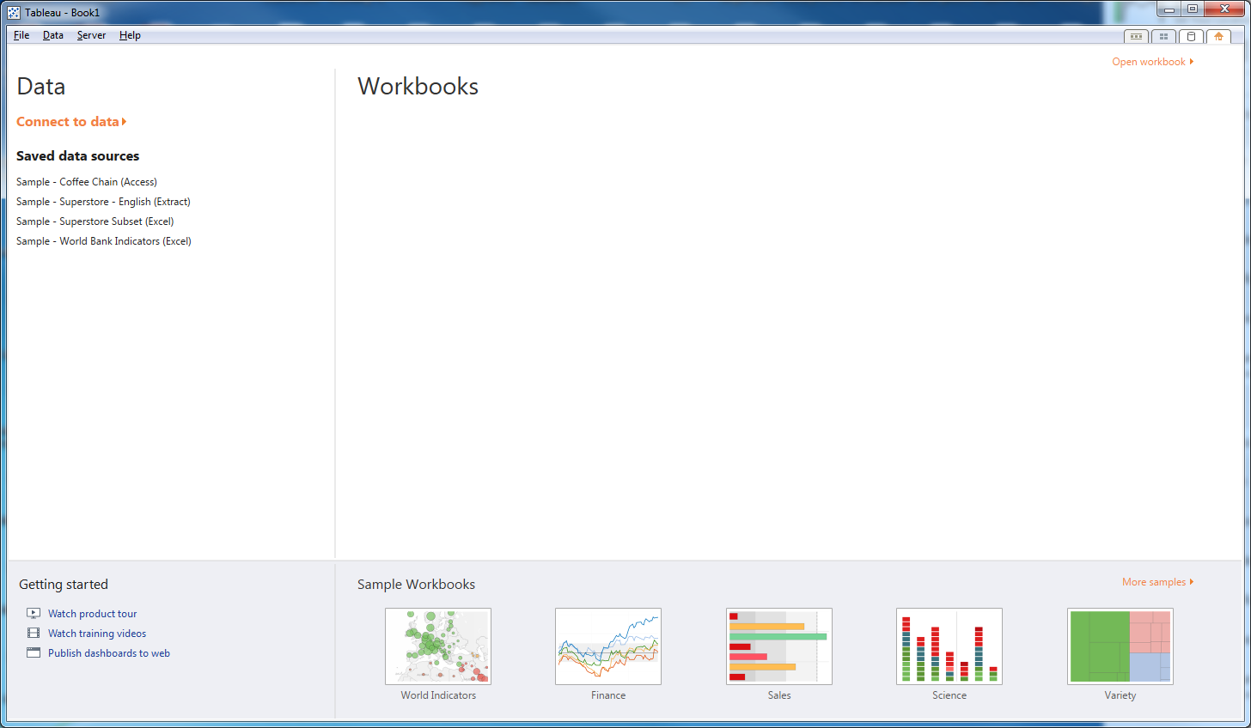

The area labeled Workbooks will display previously used workbooks (workbook history). If this is the first time you’ve opened Tableau, this will be blank. At the bottom of the screen are sample workbooks.

1. Click on the World Indicators sample workbook.

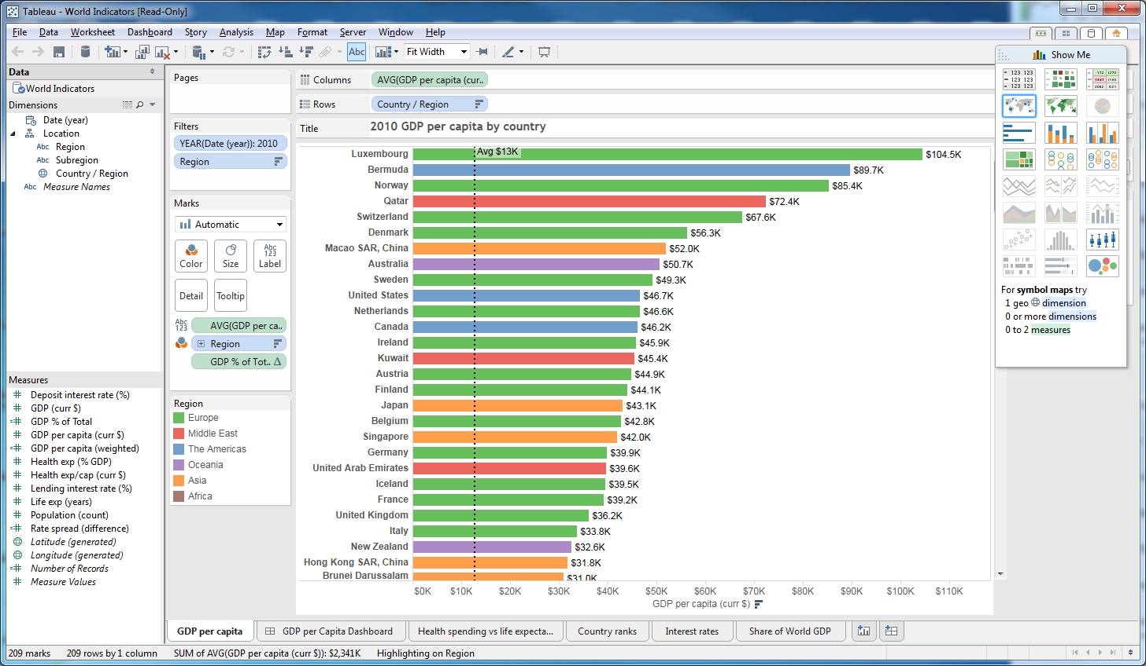

1. In the upper left corner is a section labeled Data. The data source is listed below the word Data, in this case, World Indicators
2. In the lower left corner are the data measures (columns in Excel).
   1. # means raw data
   2. =# is a calculated field
   3. # is a generated geographical field
3. In the main part of the screen is the graphic display, in this case, a bar chart where the columns are average GDP and the rows are Country
4. At the bottom are the Tableau tabs. Click on GDP per Capita Dashboard. A dashboard can have multiple views of the data simultaneously.

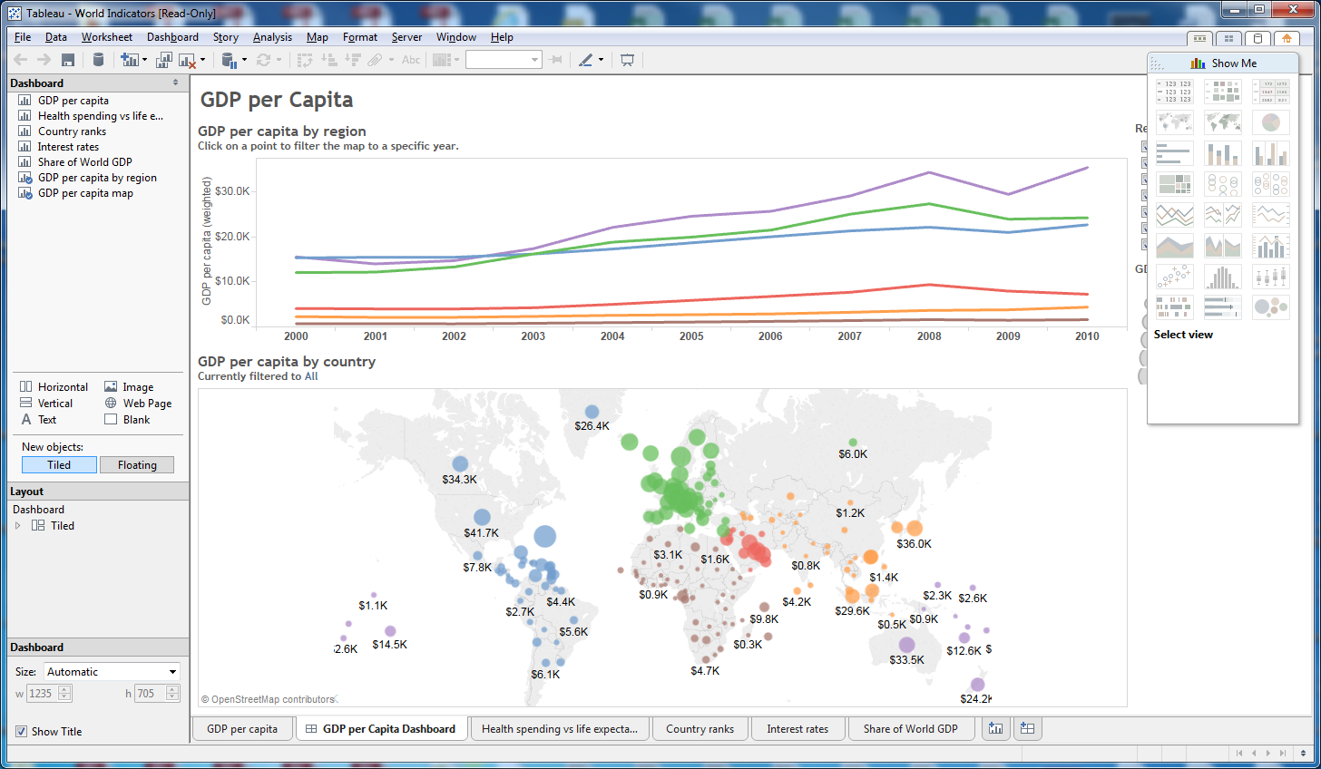

1. In this example, there is time trend data of GDP per capita over time at the top of the dashboard and a geographic representation of the data in the bottom of the dashboard.
2. Click on the tab for Health spending vs life expectancy. The X-axis is health care expenditures per capita. The Y-axis is life expectations. The countries are color-coded by continent with the legend on the left side of the screen. Which continent has the highest health care spending?

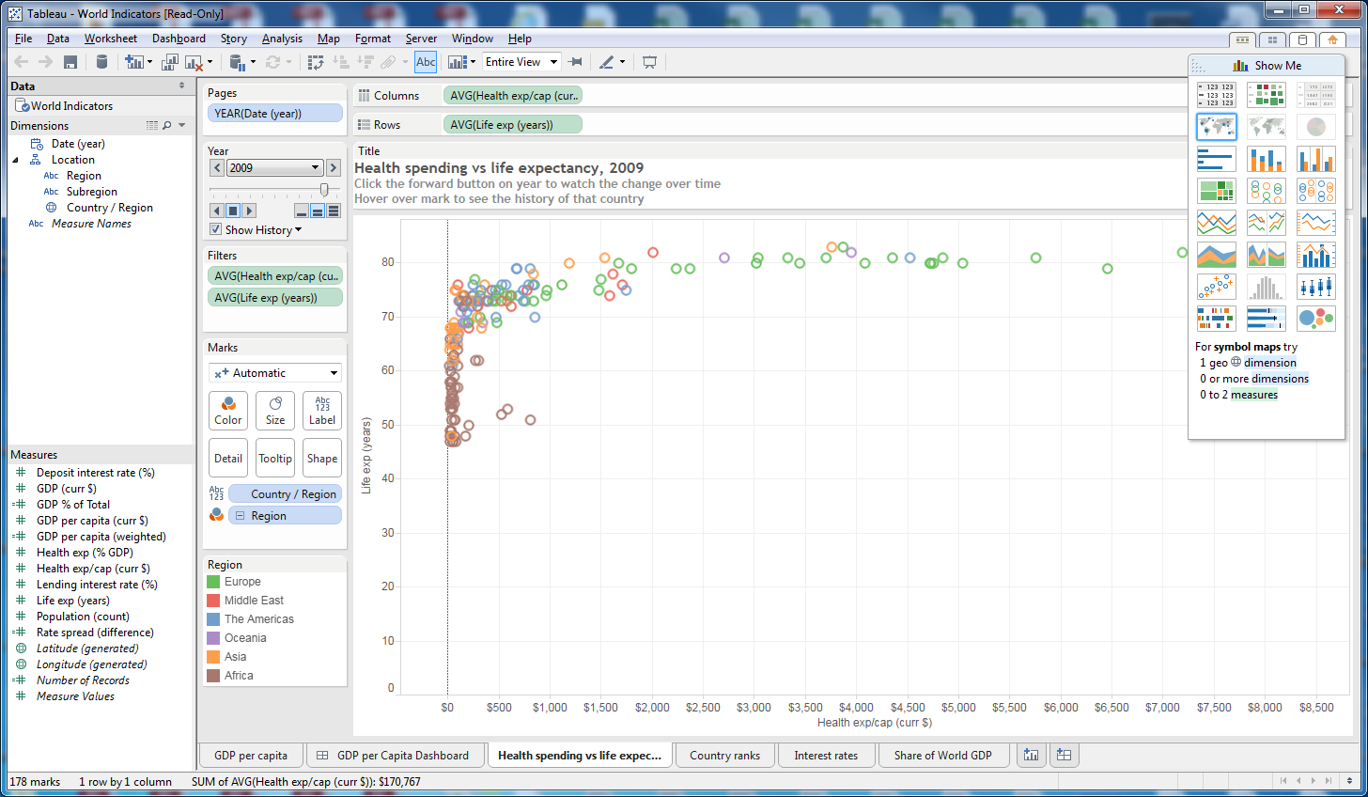

1. Click on the Country ranks tab. This is an example of tabulated data by country, similar to a Pivot Table in Excel.

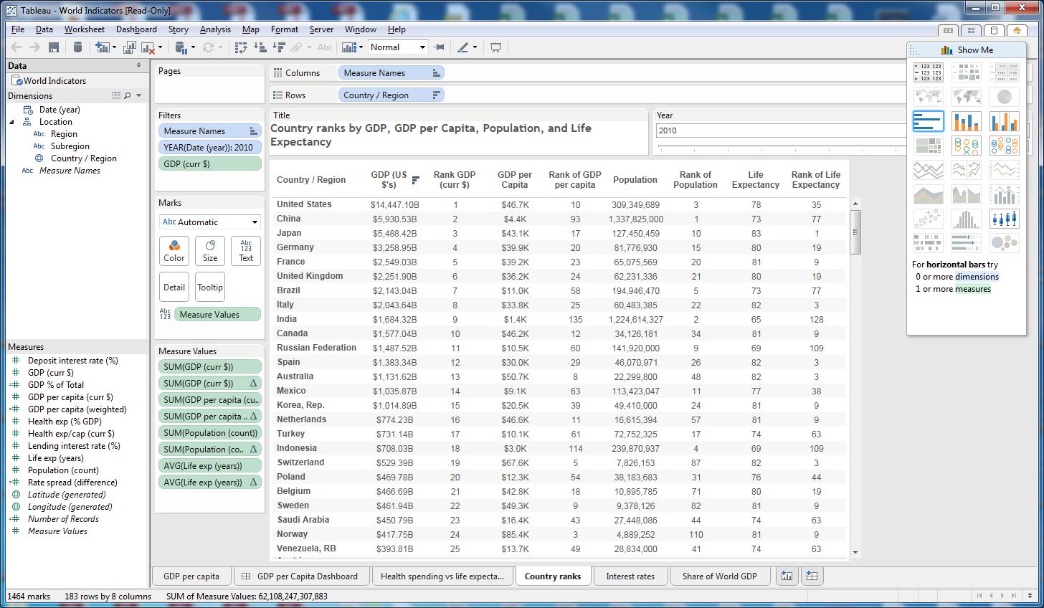

1. Click on the Interest rates tab. This is similar to the previous example, but with Region and Subregion summaries.

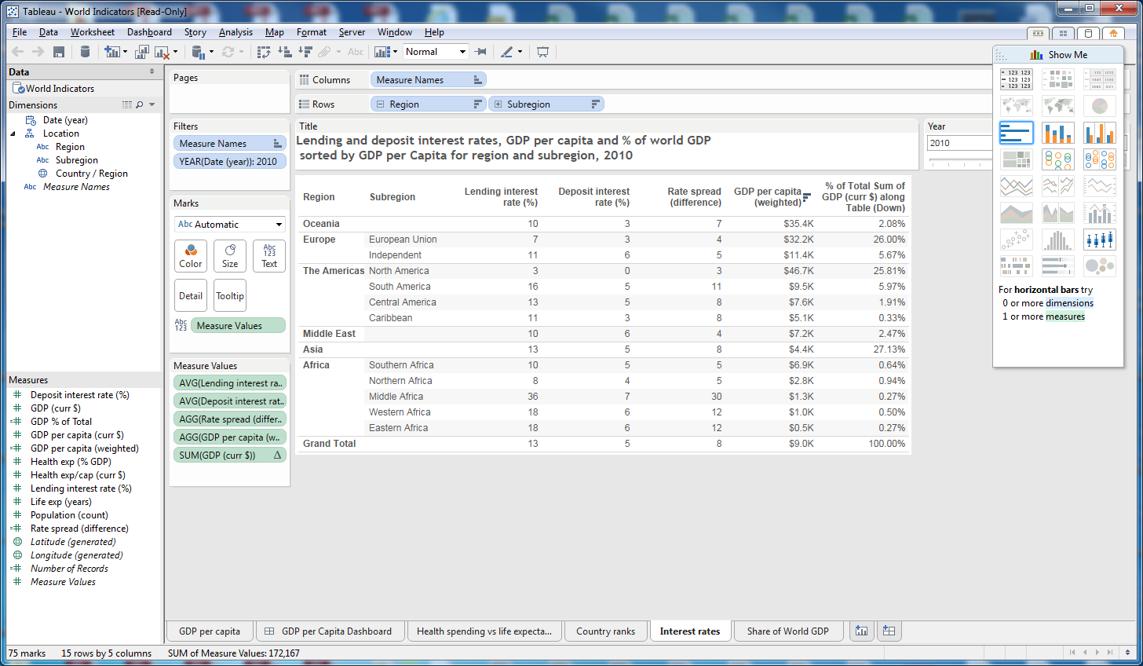

1. Finally, click on Share of World GDP. This representation uses blocks to show the relative size of GDP by country. The color coding categorizes countries by Region.

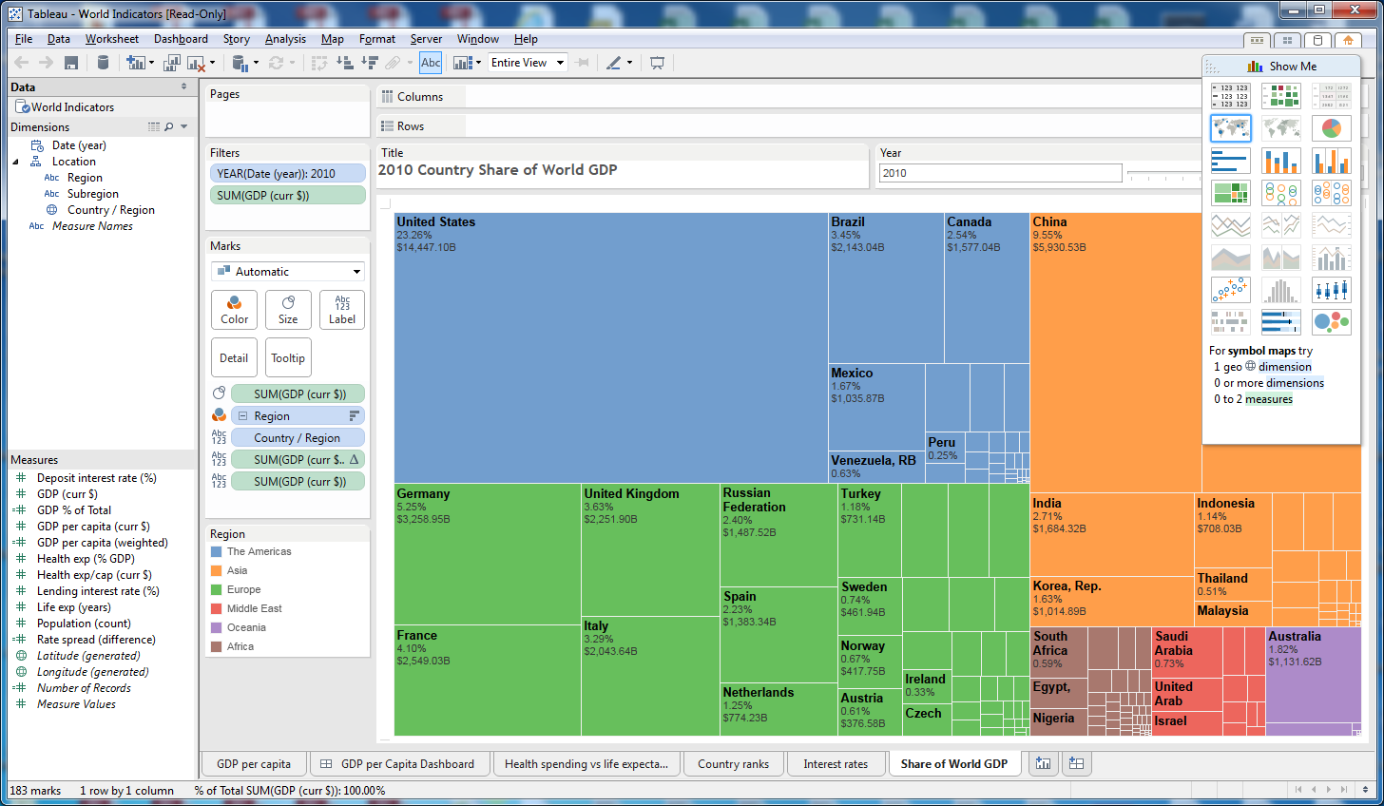

1. Move your cursor over each box. The detailed data will pop up for each box.
2. The Show Me menu in the upper right corner displays the graphic options and describes how many dimensions and measures can be used.

**Session 10.5: Download Data Using Excel**

Use the Business Analytics – Week 10 Orders.xls file for this exercise.

**Opening a new Tableau Workbook**

1. To open a new Tableau Workbook, click on File, New

**Connecting to Data in Tableau**

We will use Orders data extracted from an Excel spreadsheet to construct our dashboards. The data is shown below.

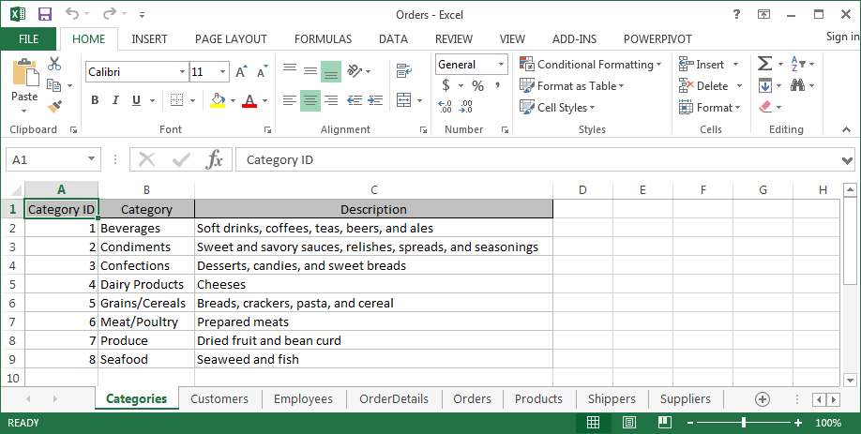

1. To connect to the orders data, click on Data, Connect to Data
2. Under the word Connect, In a File, click on Excel
3. Locate and click on your Orders Excel spreadsheet, then click Open

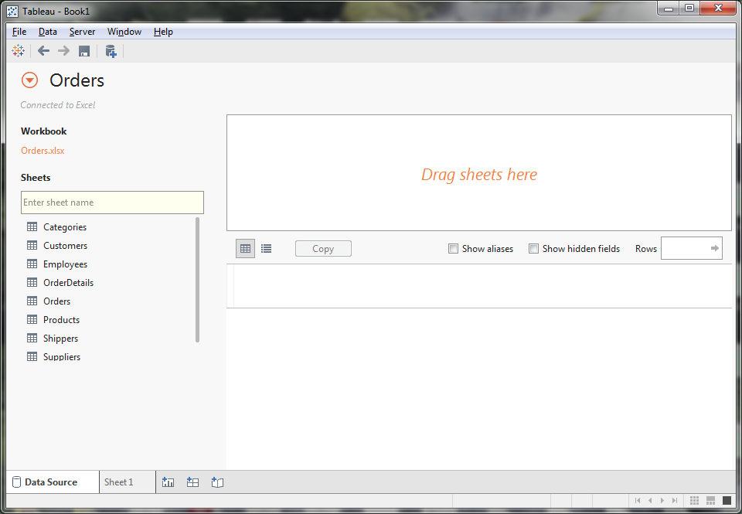

**Session 10.6: Relationships**

1. The worksheets from the Excel workbook are listed on the left. Double click on Suppliers. The table appears it the top box.

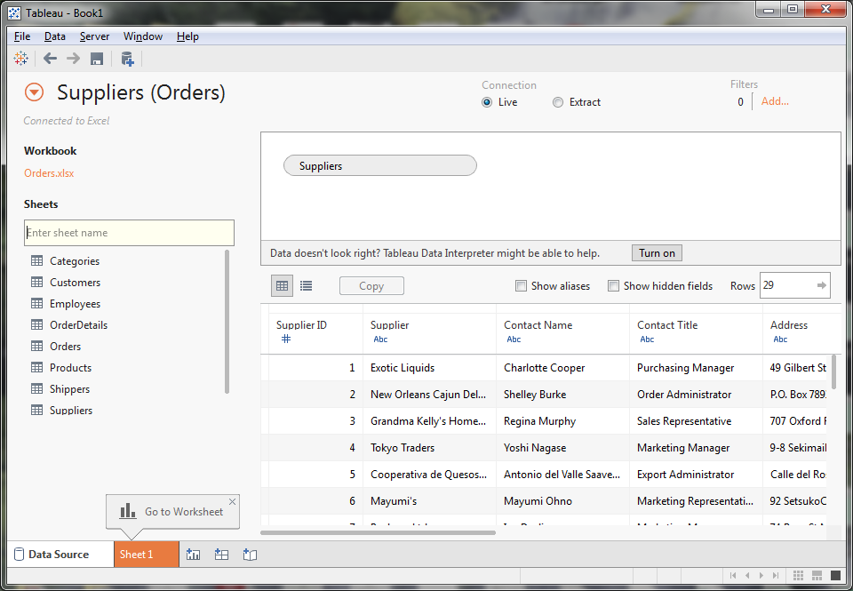

1. Next, double click on Products. Note that Products has been added to the list of tables at the top. Also, a relationship has been created. Click on the relationship. Which fields are used to create the join? What type of join is used?

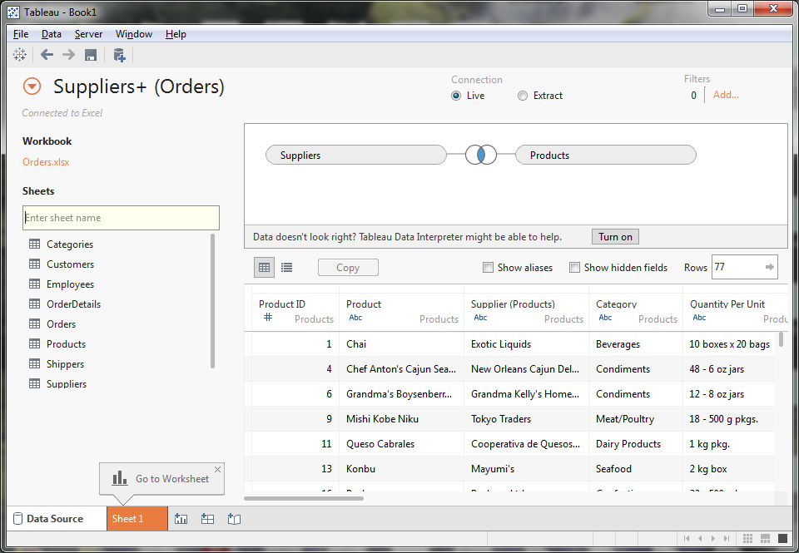

1. Next, add Categories. Again the relationship between Products and Categories is created.

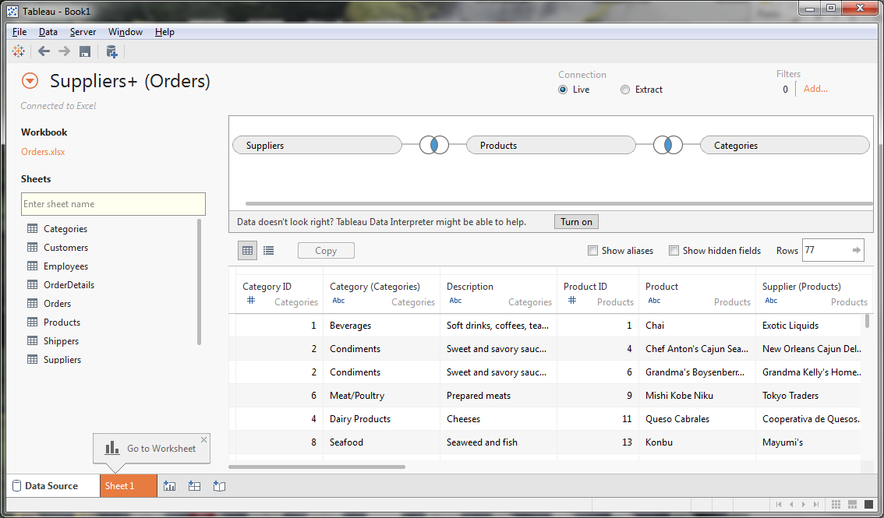

1. Next, add Order Details. The relationship links Order Details to other tables through the Products table.

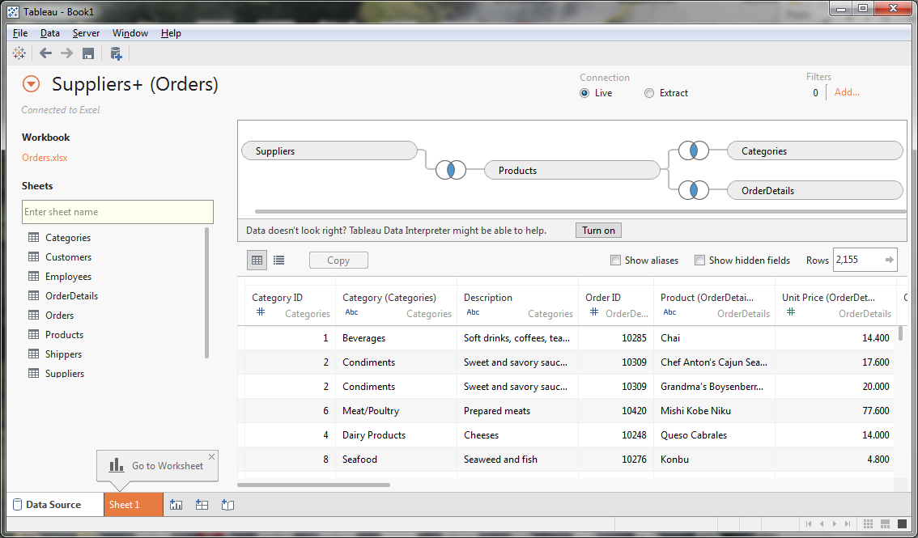

1. Next add Orders. The relationship links Orders with Orders Details

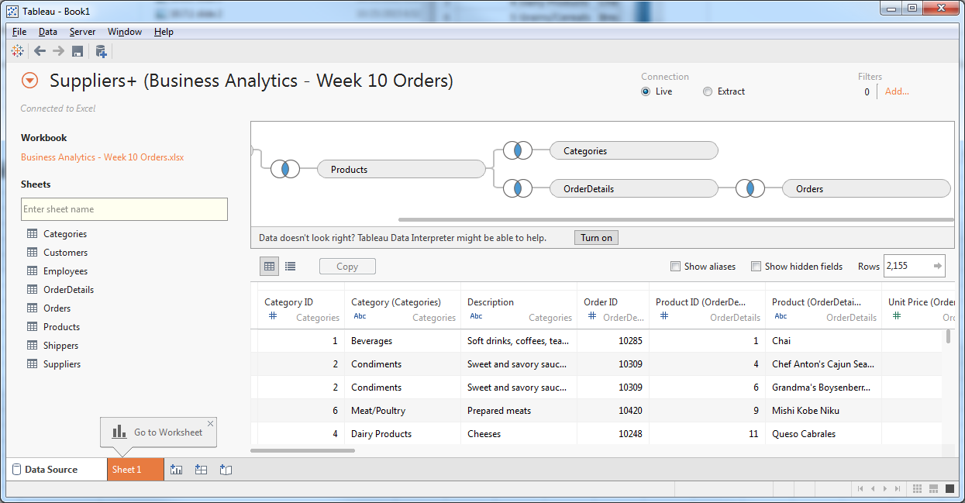

1. Finally, let’s add the Shippers table.

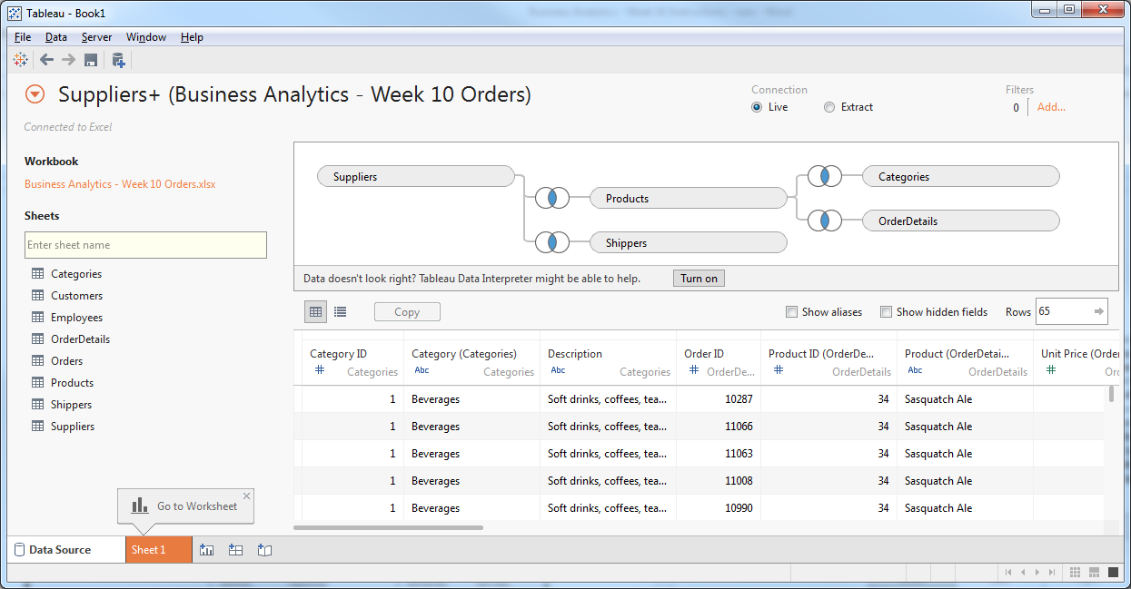

1. The Shippers table is incorrectly connected to the Suppliers table. It’s linking phone numbers, although it should join using the Shipper ID.

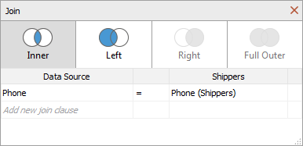

To correct this, click on the left side, down arrow, and change Phone to Ship Via in the Orders table. Click on the right side, down arrow, and change Phone (Shippers) to Shipper in the Shippers table. You will need to manually create joins when the fields have different names.

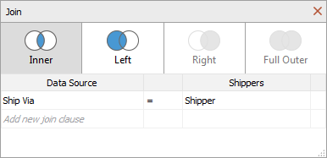

1. Click on each relationship. There are four different types of joins.
   1. Inner join: the data rows selected require that the fields (in this case, Supplier) must match from both tables; this is a simple intersection
   2. Left Join: all rows are selected from the table on the left; those rows with matching fields (Supplier) on the right table are also selected; this includes all rows from the left table and those rows from the right table that intersect
   3. Right Join: all rows are selected from the table on the right; those rows with matching fields (Supplier) on the left table are also selected; this includes all rows from the right table and those rows from the left table that intersect
   4. Full Outer Join: includes all rows from both the left and right table, inserting blanks when a value for the key field (Supplier) appears in one table but not the other

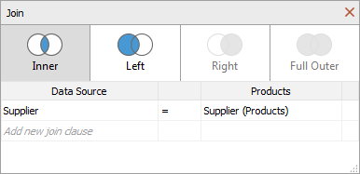

1. Save your workbook by clicking on File, Save As, then enter File name: Orders and click Save.

**Session 10.7: Building Worksheets**

1. To return to Worksheet mode, click on Go to Worksheet (version 8.3) or Go to Worksheet – Sheet 1 (version 9.0)

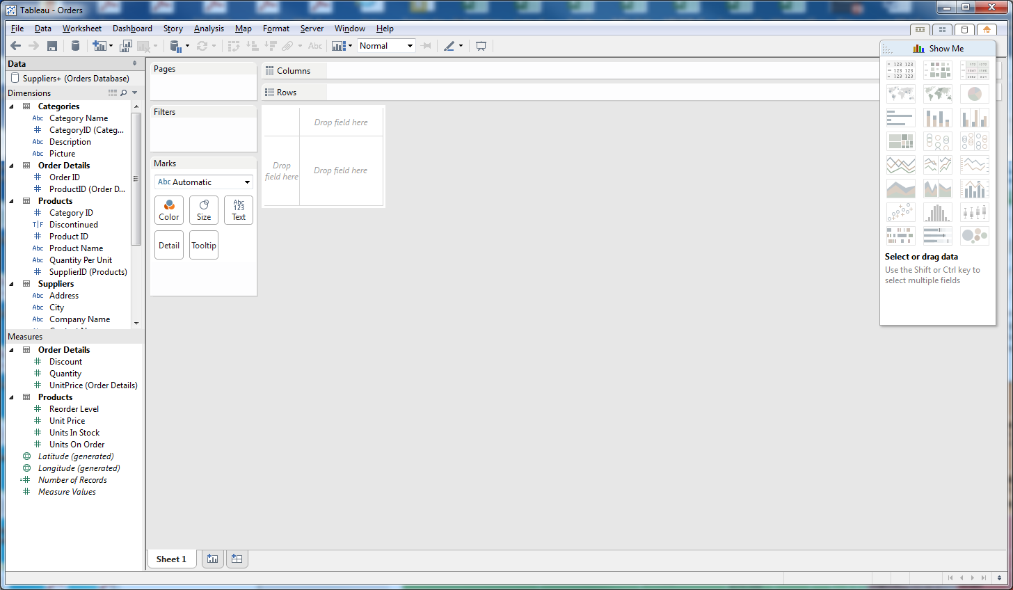

1. In the upper left, under Data, it shows that we are connected to the Orders database
2. Also in the upper left, the dimensions are listed. Dimensions are alphanumeric fields that can be used to categorize data.
3. In the lower left are the Measures. Measures are quantitative data which can be used for calculations. Only the Order Details table and the Products table have measurable data. Notice that Latitude and Longitude are generated from our raw data.
4. Near the top center of the page are sections labeled columns and rows. These will be filled in soon
5. Below the Columns and Rows sections is a Drop field here area. This is where we build our table of data (like a Pivot Table)
6. Let’s build a table with quantity ordered by category and supplier country.
7. First, from Dimensions drag Categories: Category Name to Columns
8. Next, from Dimensions drag Supplier: Country to Rows
9. Finally, from Measures drag Order Details: Quantity to the main part of the table
10. You can easily swap columns and rows by clicking on the icon at the top which shows columns and rows with an arrow between the two.

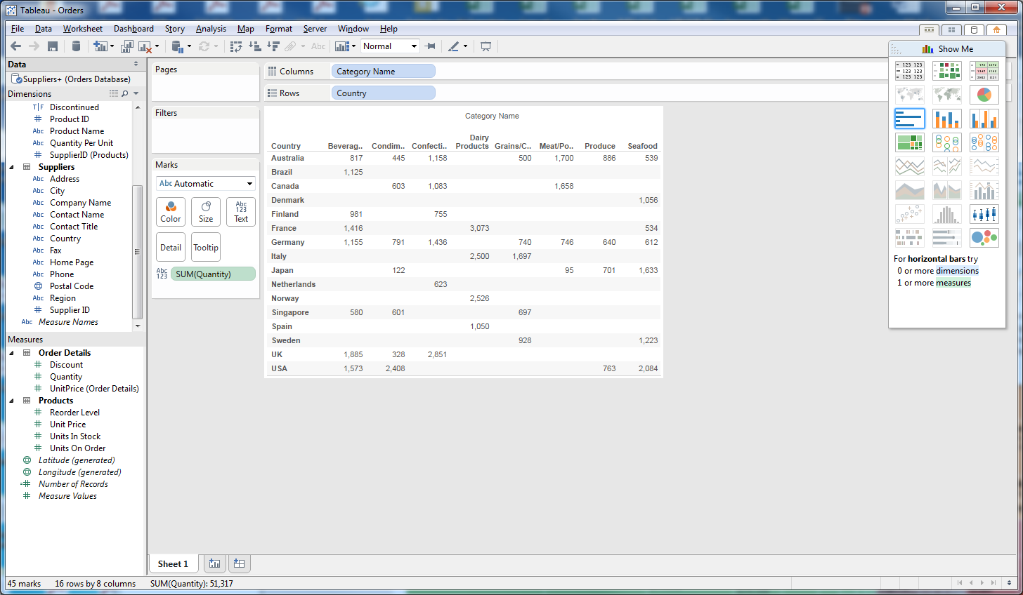

1. Let’s now experiment with different formats and representations. Go to the upper right of the screen labeled Show Me. Move the cursor over each of the options in the Show Me box. The pop-up identifies how many dimensions and measures are supported by each option.
2. Click on the top middle icon in the Show Me box. This displays size graphic instead of numbers, where the legend is on the left.

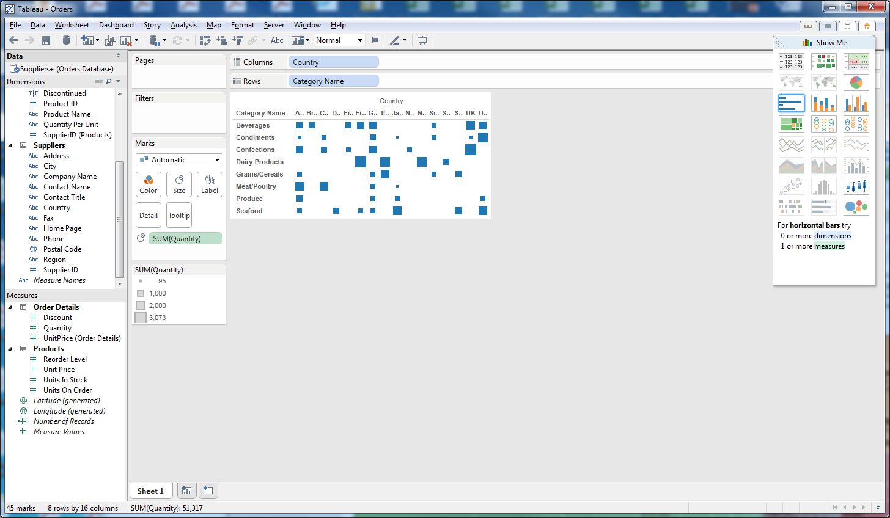

1. Next, click on the icon in the upper right of the Show Me box. This is our data table with conditional formatting applied. The legend for the color scale is on the left.

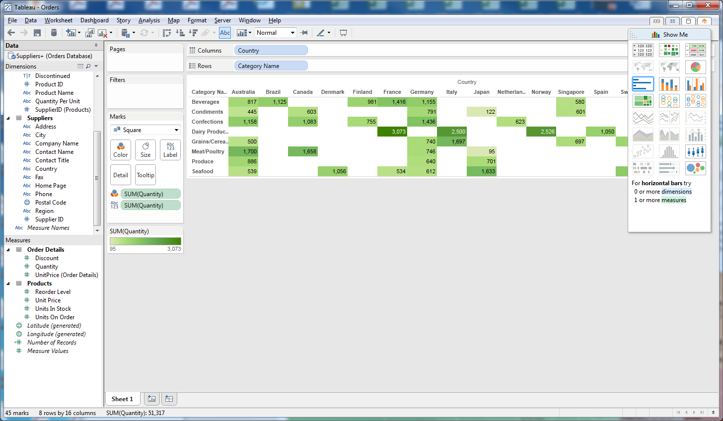

1. The colors for conditional formatting can be edited. Move the cursor over SUM(Quantity) which displays the legend, click the down arrow, then click Edit Colors.
2. Change the Palette from Automatic to Red-Green Diverging

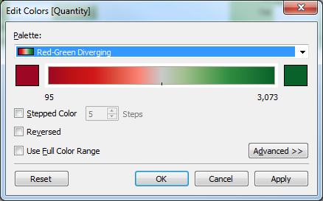

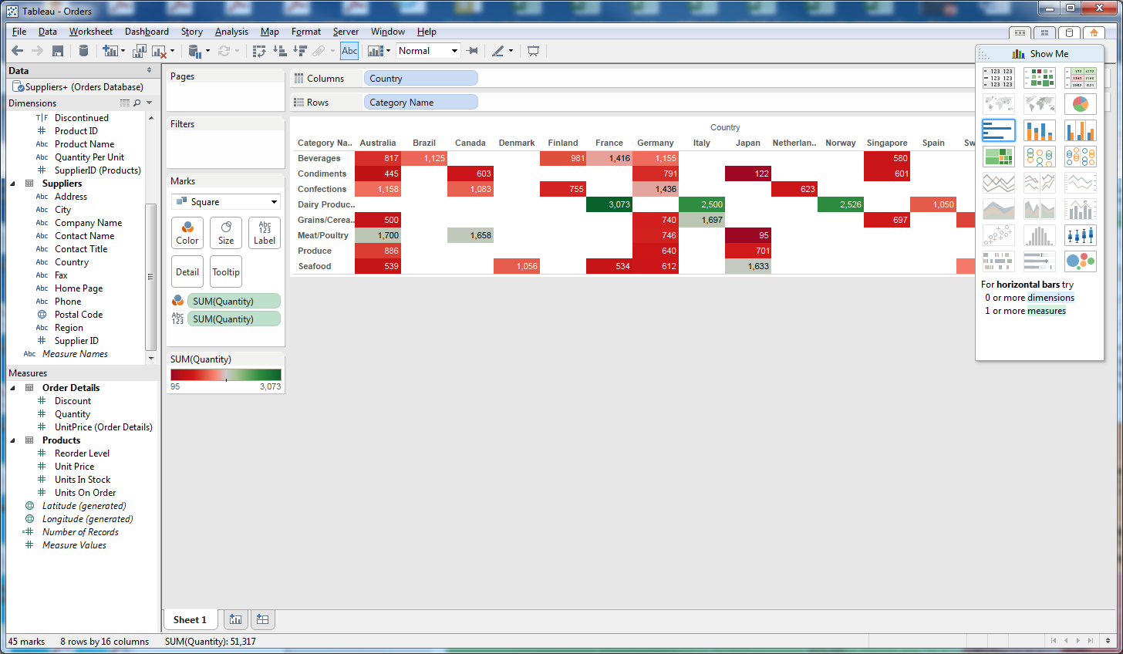

1. Next, try the Pie Charts in Show Me. Note that all data is collapsed to a row with a pie chart for each row

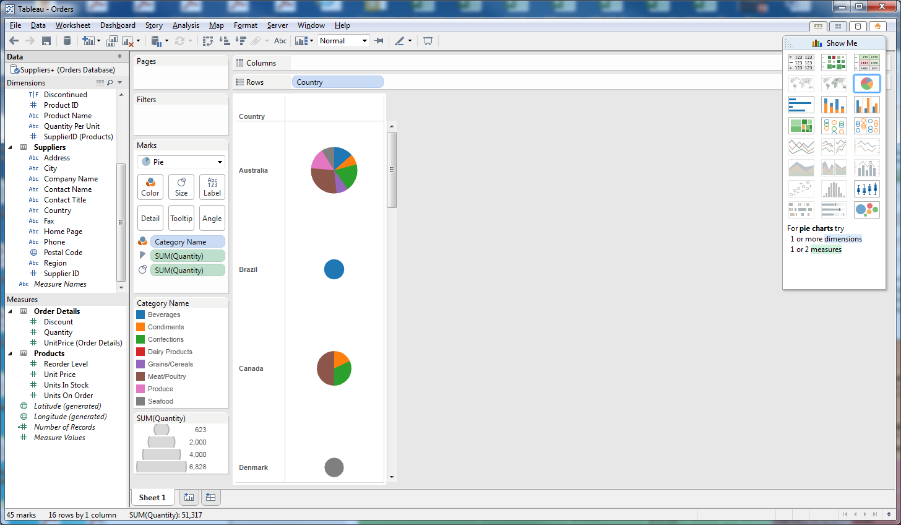

1. Horizontal bar charts: Categories are countries are grouped. Drag Category Name after Country; what happens?

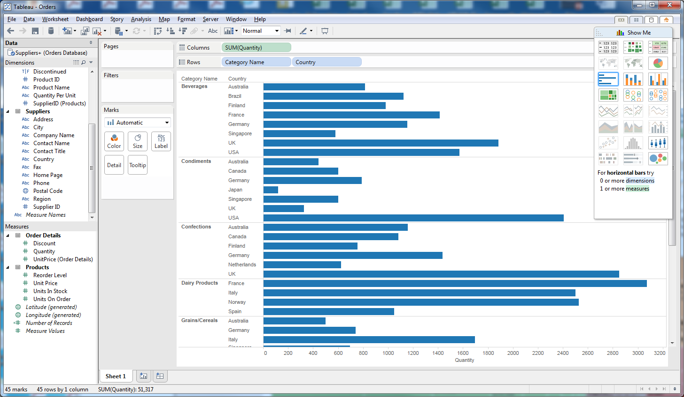

1. Stacked bar charts: Click on Confections in the Legend. What happens? Hold down the control key and click on Beverages, Confections, and Dairy Products. What happens?

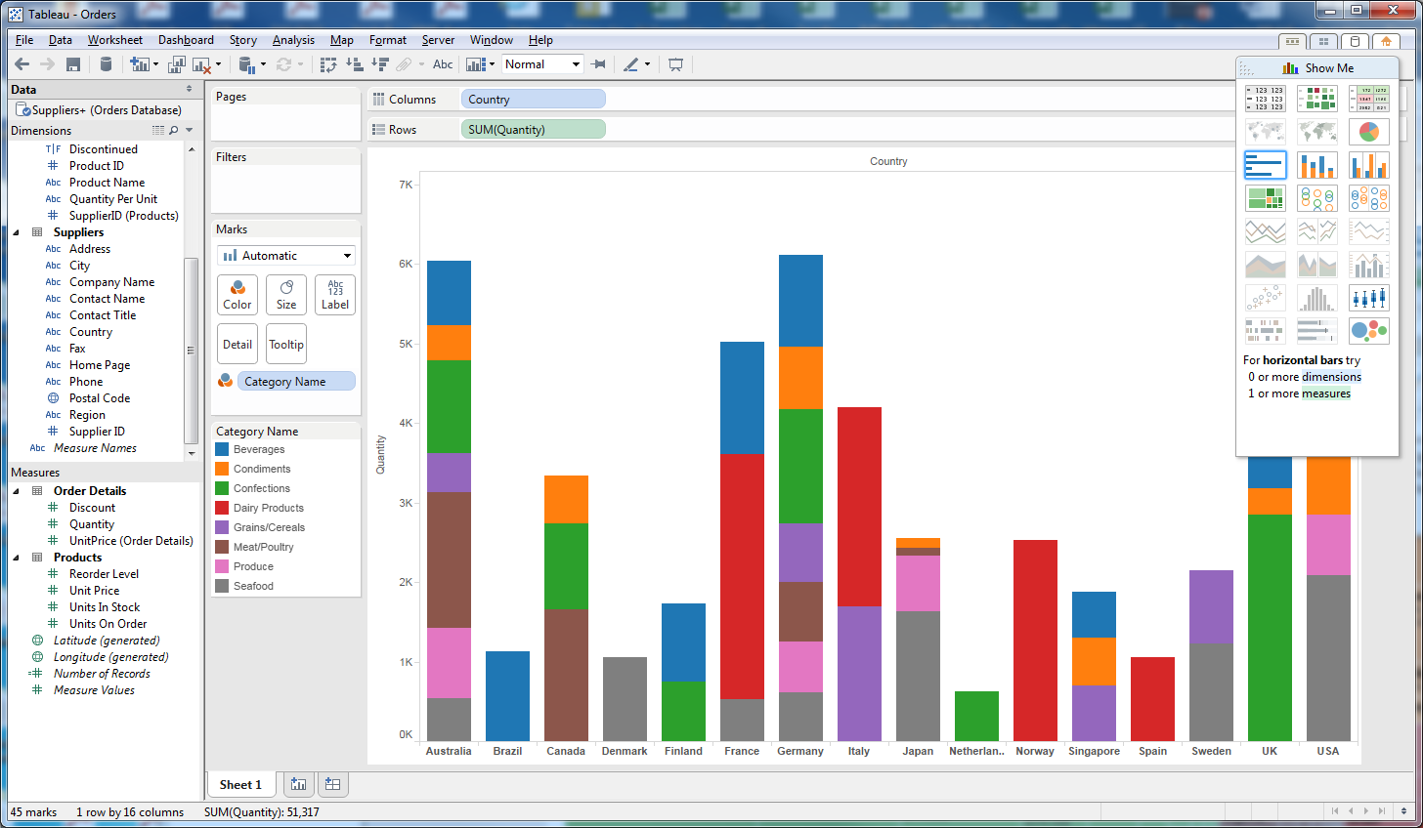

1. Side-by-side bar charts: Click on Beverages at the top of the graph.

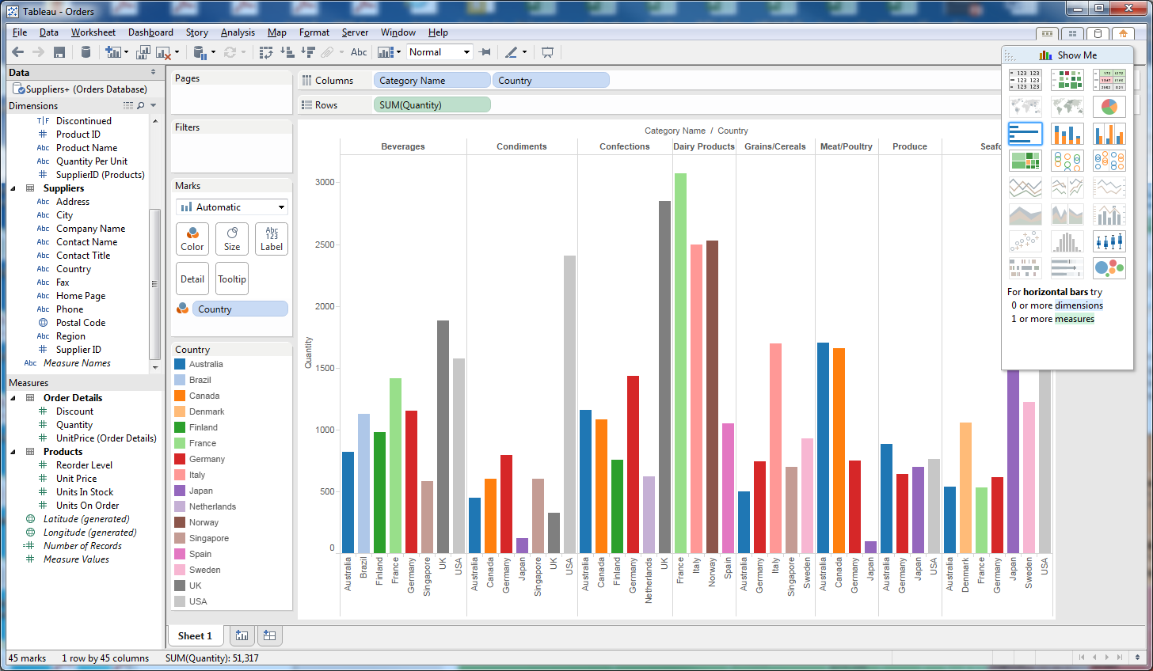

1. Treemaps display data by translating the numeric values into an area.

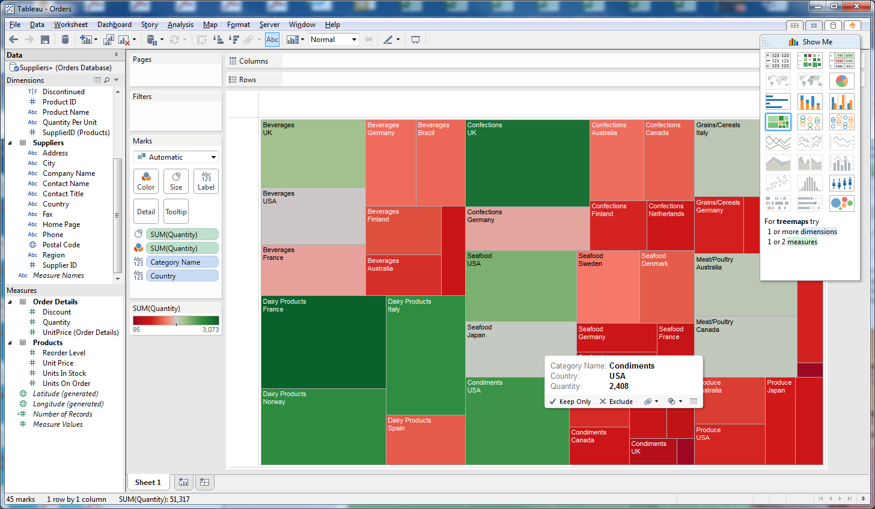

1. Circle views display the quantity of product by country, with the color of circle reflecting the category name.

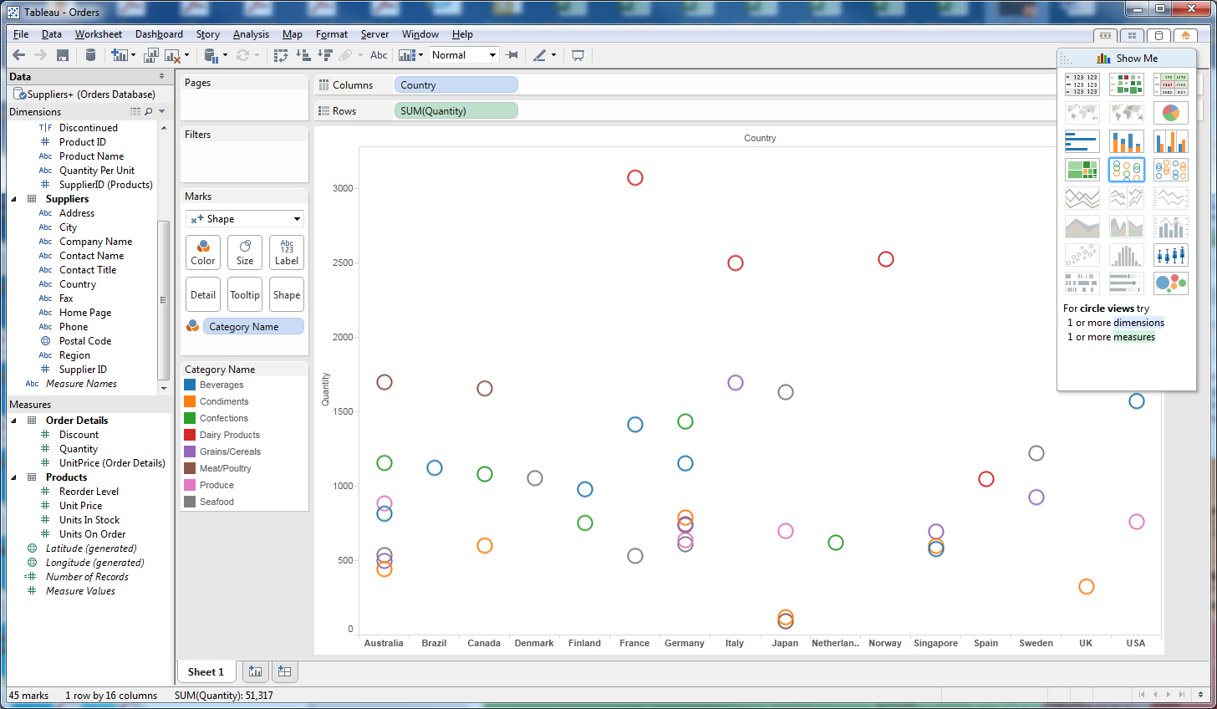

1. Side-by-side circle view swaps the dimensions

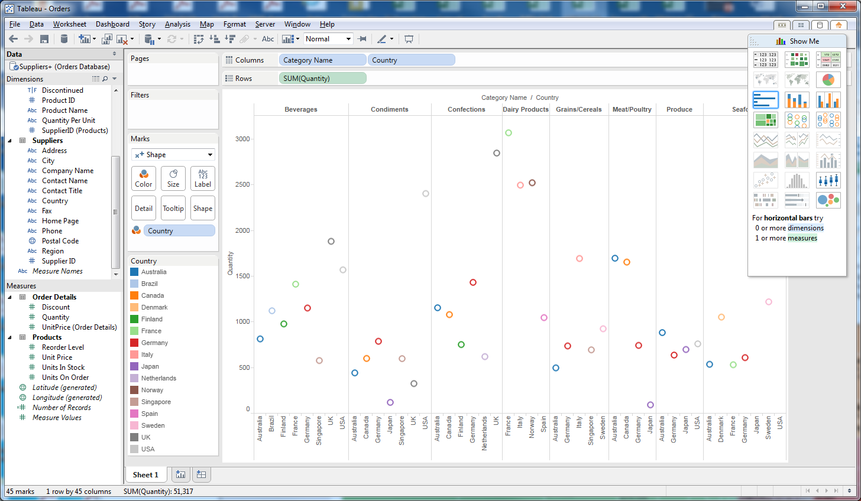

1. Box and whisker portray data ranges from minimum, 25%-ile, median, 75%-ile, and maximum.

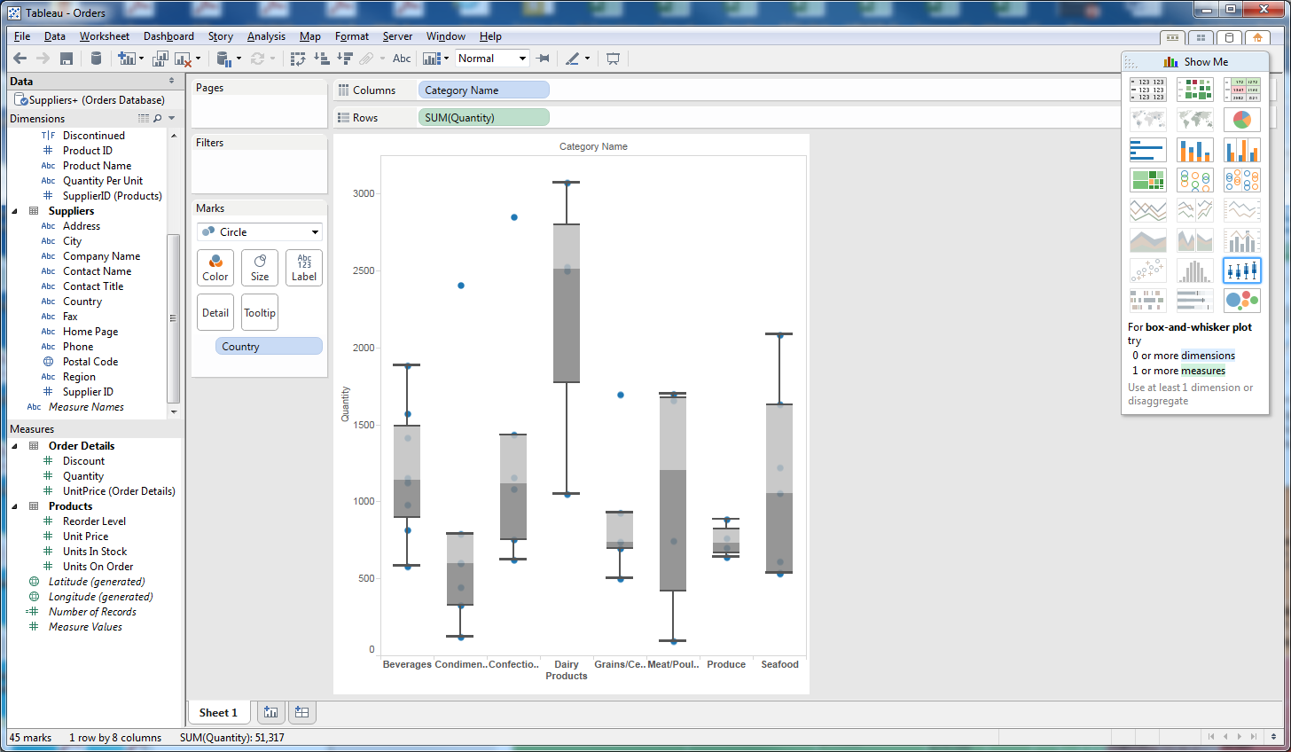

1. Packed bubbles use the area of a circle (bubble) to reflect the magnitude of the numbers

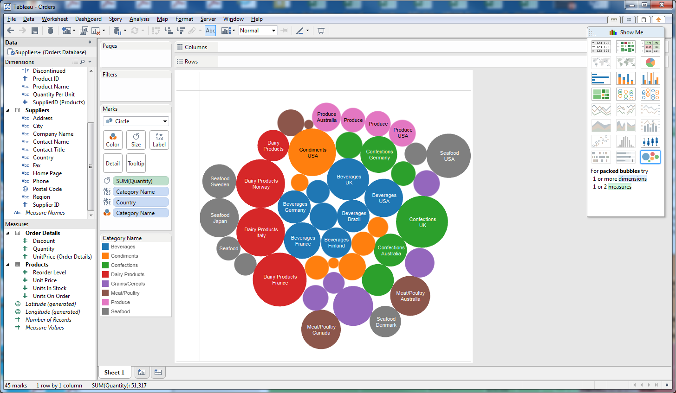

**Session 10.8: Adding New Geolocations**

**In version 8.3, you will need to set up Geolocations. Version 9.0 automatically detects these. Steps 1, 2, and 3 will not be necessary if you have version 9.0.**

Several of the graphs in Show Me were grayed out. This is because data was not available to plot specific graphs. Move your cursor over the pictures of world maps. Each requires a geo dimension. In reviewing the dimensions on the left side of the screen, only Postal Code has the symbol for geo dimension. Tableau will automatically scan data and try to identify geo dimensions, but it’s not perfect. Other geographic locations include City and Country, but they are listed as Abc, which means alphanumeric data not associated with a location. Let’s convert Suppliers: Country to a geo location.

1. Put your cursor over Country in the Suppliers table. A drop down arrow should appear.
2. Click on the drop down arrow and select Geographic Role, then Country/Region
3. Note that the symbol in front of Country has changed to a geo location. Also note that the map icons under Show Me are now available.
4. Click on the map icon on the left of Show Me. The charts are for each Category.

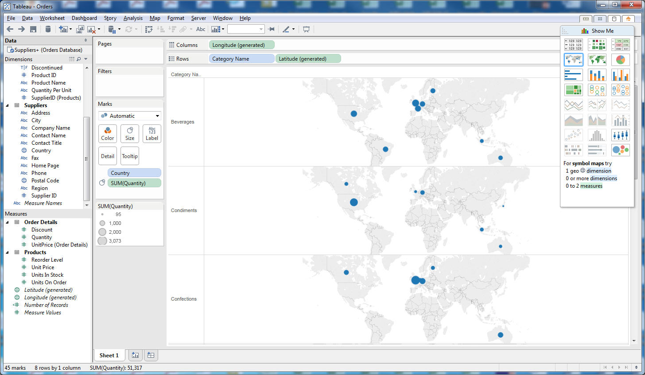

1. Click on Category Name in Rows, then delete. How did the graph change?

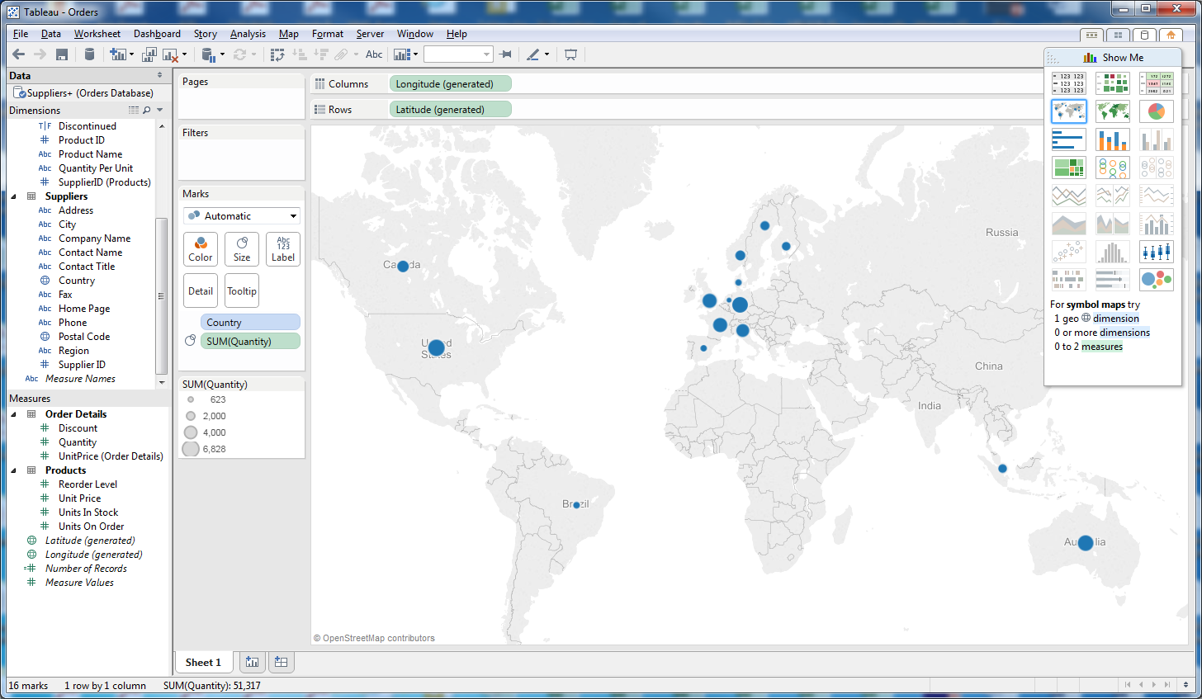

1. Now click on the second map icon in Show Me.

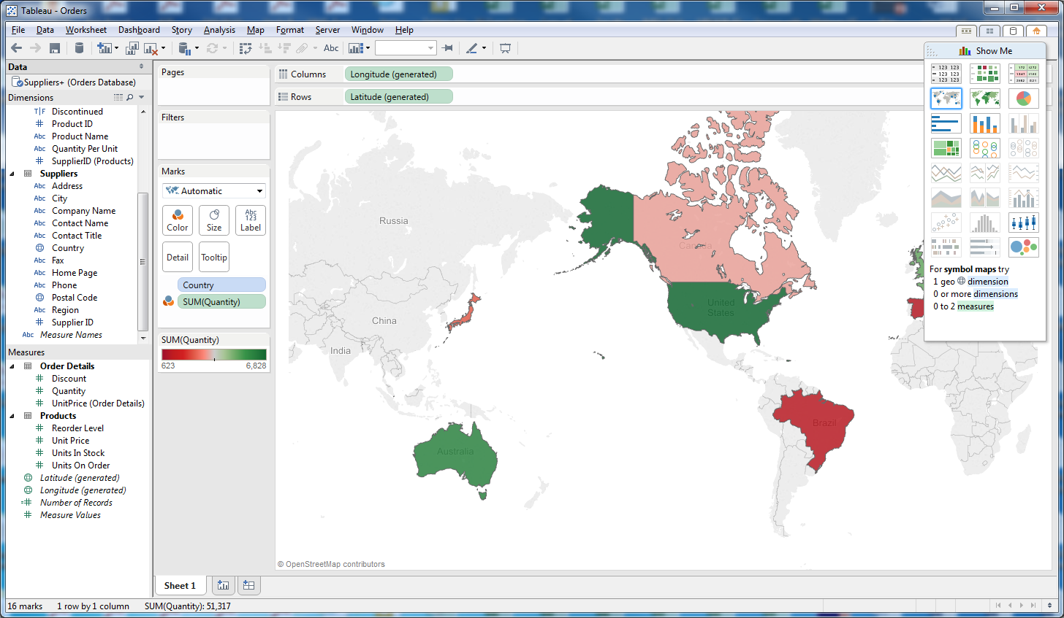

1. If you wanted to use City instead of Country, what would you do differently?
   1. Click on City, Geographic Role, City
   2. Drag City from Suppliers and drop over Country in Marks

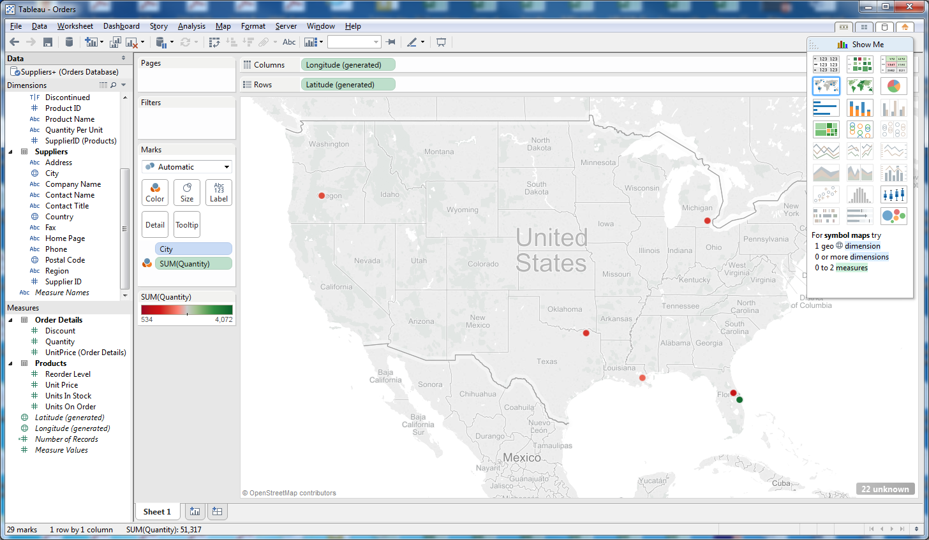

1. What limitation does automatic translation of cities reveal? Hint: are there any international cities?
2. Change back to Country.

**Session 10.9: Adding Calculations**

Sometimes you will want to create new values which are calculated from data in the worksheet. For example, let’s calculate the value of an order, which is Quantity * UnitPrice * (1-Discount).

1. At the top of the worksheet, click on Analysis, Create Calculated Field.
2. Replace the name Calculation1 with Order Value
3. Drag Quantity in the blank area below the title Order Value
4. Enter *
5. Drag UnitPrice [Order Details] into the box
6. Enter *, then (1-
7. Drag Discount into the box
8. Enter ), then click OK.
9. Order Value now appears in Measures

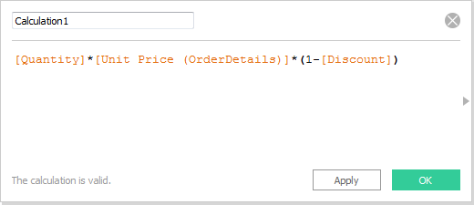

1. Return to the table format in Show Me (upper left corner). Make sure that Category is in Columns, Country is in Rows, and Order Value is in the table.

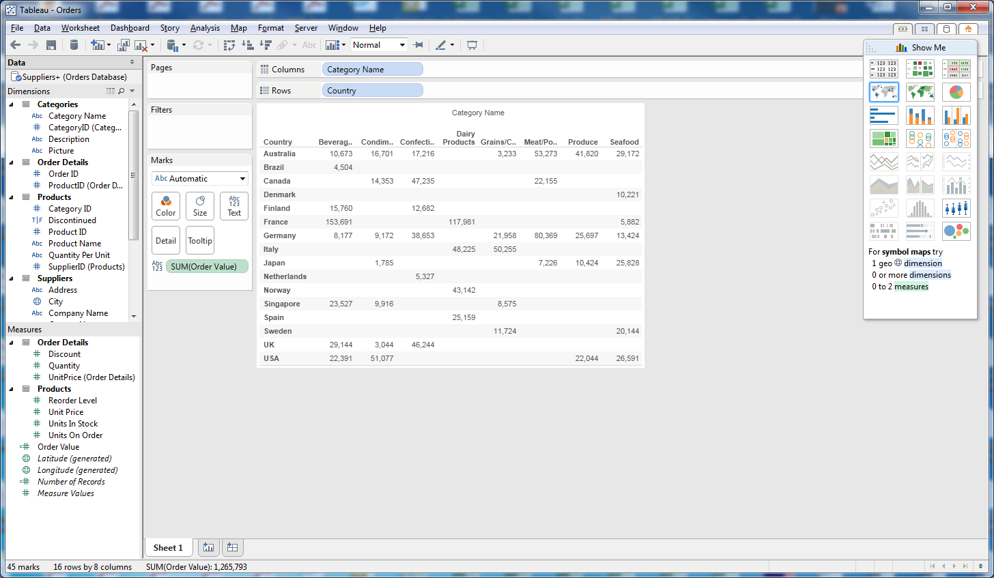

1. Change to map format (use map icon in Show Me)

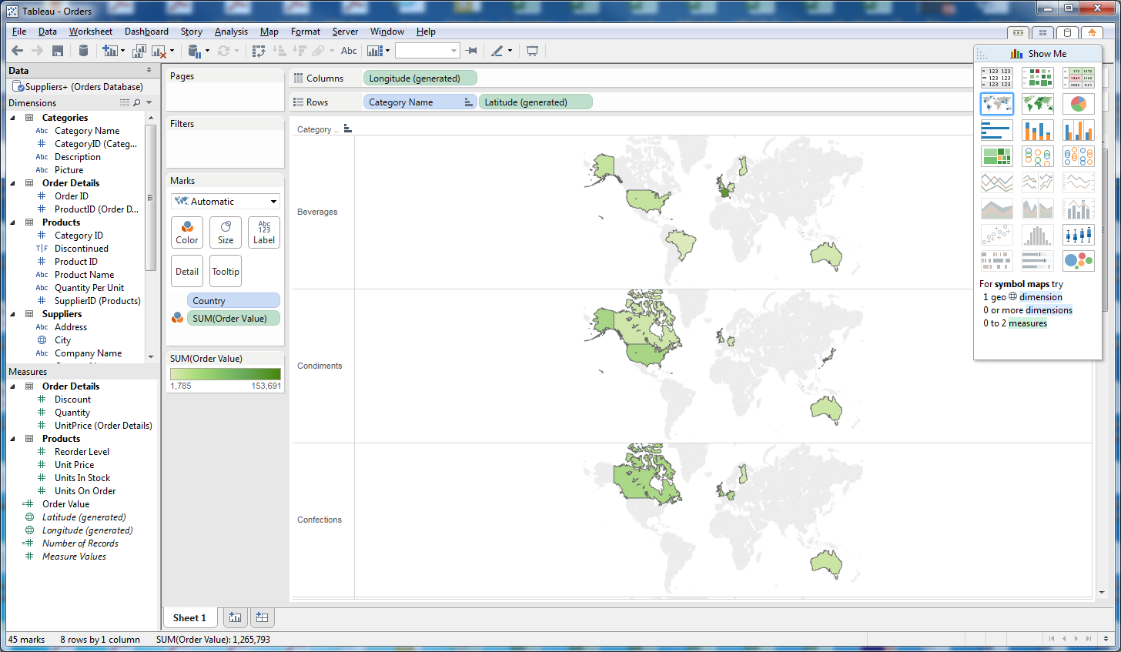

1. Drop Category Name by clicking on it and pressing the delete key to consolidate for all categories. To hide the Show Me box, click on the words Show Me.
2. Change the colors by clicking on the drop down arrow next to SUM(Order Value), Edit Colors, then Area Red-Green Diverging.

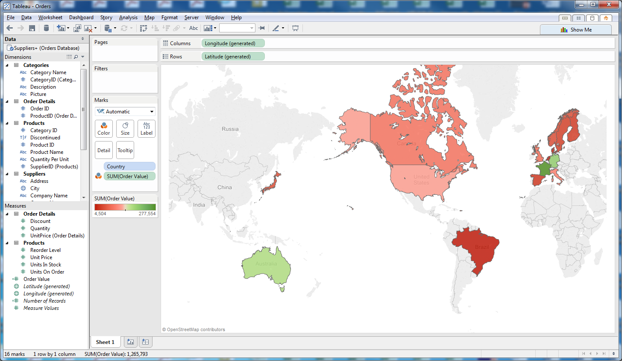

1. There are a variety of format options for maps. Click on Map at the top of the screen, then Map Options. Change Background Style to Normal and check the Coastline box.

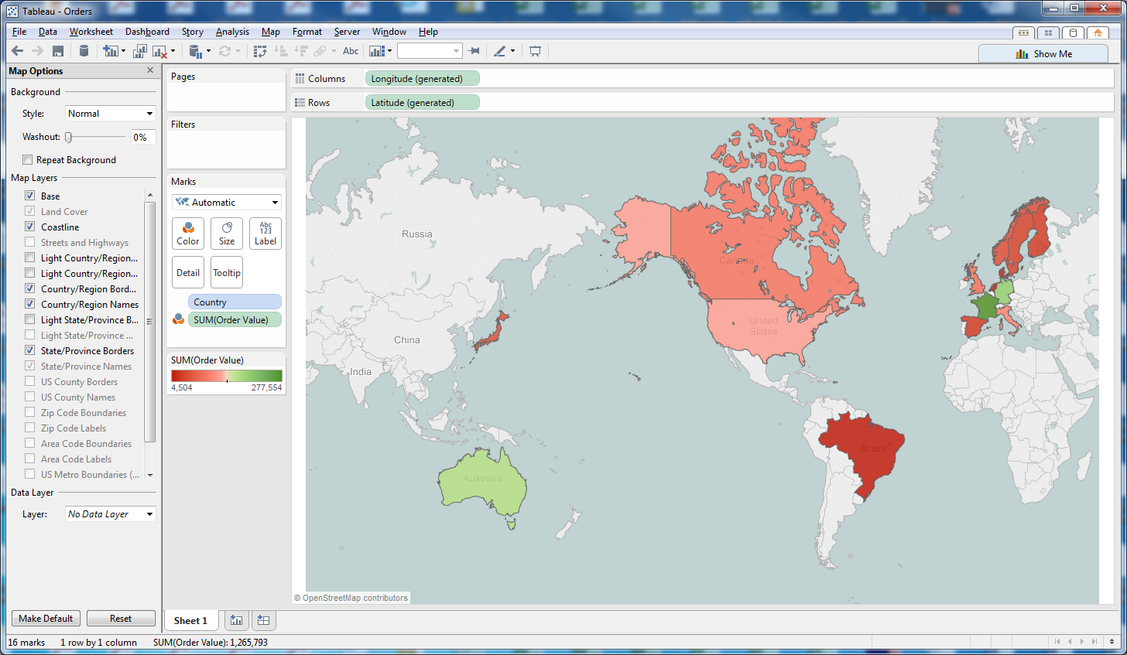

1. Change Background Style to Dark, Washout to 50%.

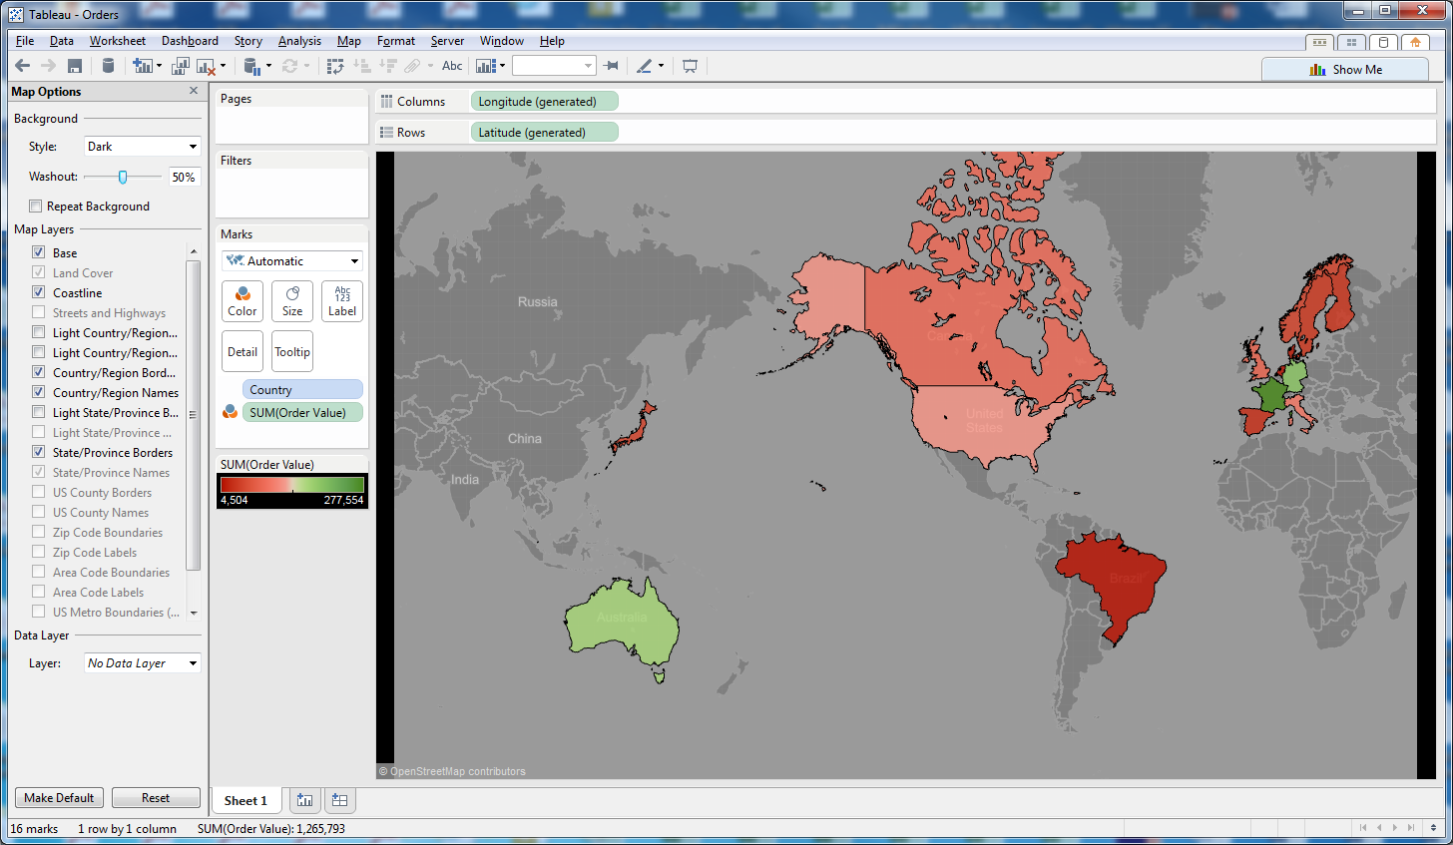

**Session 10.10: Filters**

Just like Excel, you can add filters to your data. Using the previous map of Order Value, let’s add a filter for Category.

1. Drag Category Name to the Filters box. Click on All, then OK. The map should not change, but Category Name will remain in the Filters box.
2. In the Filters box, place your cursor over Category Name, click the down arrow, then Filter
3. Uncheck everything except Beverages. (You can click None, then Beverages). Click OK.
4. The new map only reflect Beverages.

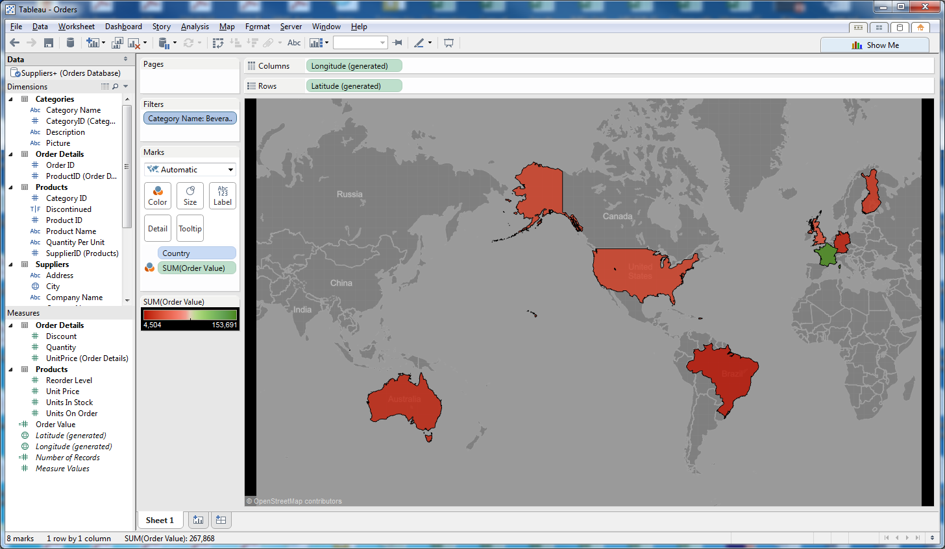

**Pages**

The Pages feature allows you to perform a filter, with each Category on a different page.

1. Drag Category Name to the Pages box.
2. The arrows below are play buttons. Click on the right arrow to play through the pages.
3. Click on the picture of a screen for full screen presentation) mode; escape to return.

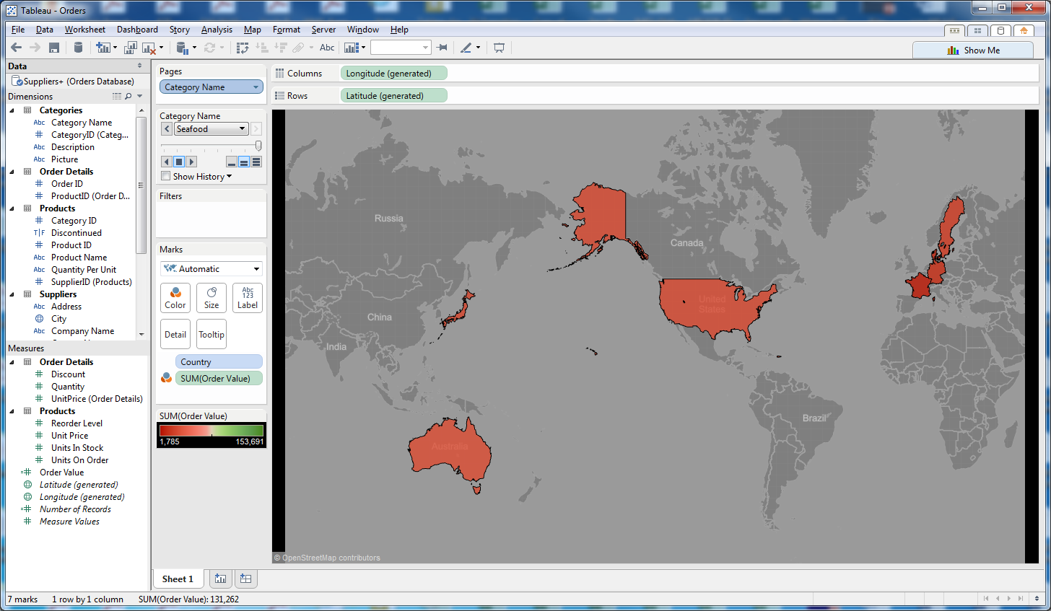

**Session 10.11: Building Dashboards**

In this section, we will move from building worksheets to building dashboards. A dashboard is simply a collection of worksheets.

1. At the bottom of the screen is the label Sheet 1. Rename this by double clicking on Sheet 1, the renaming it GlobalOrderValue
2. Next to GlobalOrderValue is an icon for New Worksheet. Click on the icon. Sheet 2 should appear.
3. Drag Category to Columns, Country to Rows, and Order Value to the center of the table
4. Rename Sheet 2 OrderValueTable
5. Click on New Worksheet again. Sheet 3 should appear.
6. Drag Category to Columns
7. Drag Units in Stock to Rows, then also drag Units on Order to Rows
8. Rename Sheet 3 Inventory

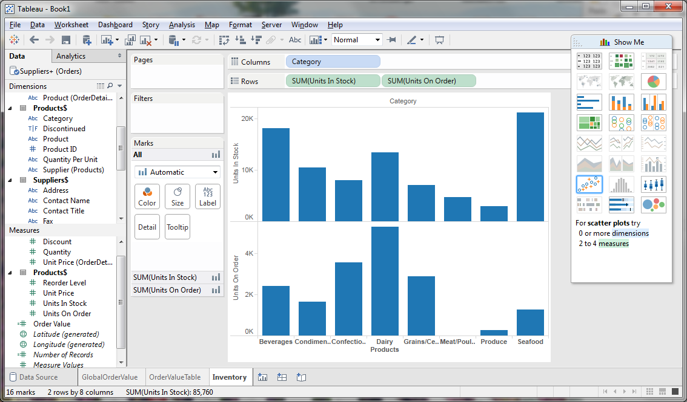

1. To create a dashboard, click on the icon for New Dashboard
2. On the left side of the screen, each of your Worksheets should be listed.
3. Drag the Inventory worksheet to “Drop sheets here”
4. Drag OrderValueTable to the bottom of the screen
5. Drag GlobalOrderValue to the lower right of the screen
6. Notice that OrderValue legend is taking up the entire right side of the screen. Right click on the Legend, then click Floating
7. Click on the floating legend and drag it into the map.

